**HTML** (Hypertext Markup Language) that formats the **structure** of a webpage. It is stored in a standard text format and contains tags that define the page layout and content of the webpage, including the text, tables, images, and hyperlinks displayed on the webpage. HTML files are widely used online and displayed in web browsers.

**>>Hypertext**: text (often with embeds such as images, too) that is organized in order to connect related items

**>>Markup**: a style guide for typesetting anything to be printed in hardcopy or soft copy format

**>>Language**: a language that a computer system understands and uses to interpret commands.

----------TOOLS---------------

* HTML is the skeleton,
* CSS is the skin,
* and JavaScript is the circulatory, digestive, and respiratory systems that brings the structure and the skin to life.

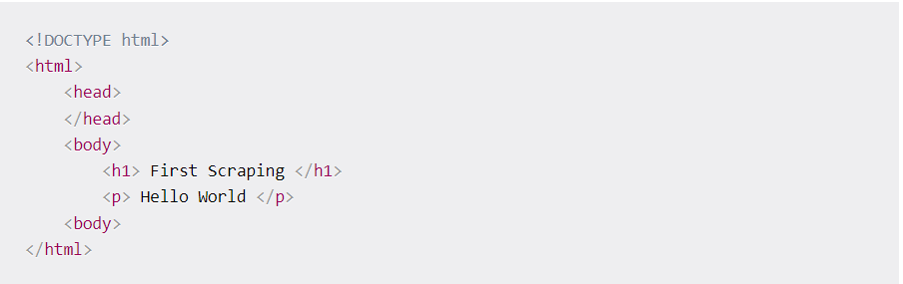----------EXAMPLE---------------

This is the basic syntax of an HTML webpage. Every <tag> serves a block inside the webpage:  
1. <!DOCTYPE html>: HTML documents must start with a type declaration.  
2. The HTML document is contained between <html> and </html>.  
3. The meta and script declaration of the HTML document is between <head>and </head>.  
4. The visible part of the HTML document is between <body> and </body>tags.  
5. Title headings are defined with the <h1> through <h6> tags.  
6. Paragraphs are defined with the <p> tag.

Other useful tags include <a> for hyperlinks, <table> for tables, <tr> for table rows, and <td> for table columns.

Also, HTML tags sometimes come with id or class attributes. The id attribute specifies a unique id for an HTML tag and the value must be unique within the HTML document. The class attribute is used to define equal styles for HTML tags with the same class. We can make use of these ids and classes to help us locate the data we want.

The <span> tag is an inline container used to mark up a part of a text, or a part of a document.

The <div> tag **defines a division or a section in an HTML document**. The <div> tag is used as a container for HTML elements - which is then styled with CSS or manipulated with JavaScript